**@ HOME SCIENCE DISCOVERY MISSIONS – TITLE HERE**

**Protocol**

1.

**What Do We Need?**

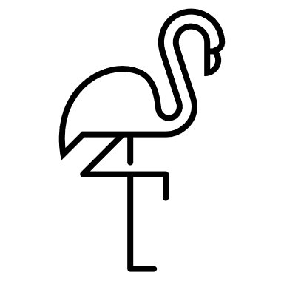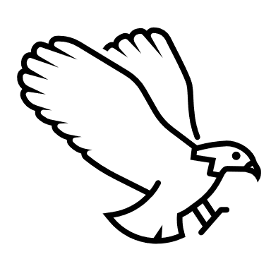



**YOUR MISSION REPORT**

*-*



**Did you know?**



Learn more!

Video here:

### Student feedback - How did you like this mission?



not at all not much  a bit  liked it  liked it a lot  liked it best

### Family feedback - How did you like this mission?



not at all not much  a bit  liked it  liked it a lot  liked it best

**Did you use the ‘Learn more!’ resources?  Yes  No**

**What was good/bad about this mission?**