FINNISH NATIONAL SYMPOSIUM OF MUSIC SCHOLARS 2024 “ECHOES AND REFLECTIONS”
25.–27.3.2024 UNIVERSITY OF EASTERN FINLAND, JOENSUU
Technical information for the performers //
On the seminar hall can use PC with Windows (in room), but there’s possibility to also connect laptop to the system by HDML-cable. There’s also option to connect mobile phone or use document camera.
The laptop can connect to the system by HDMI-cable. There is also bundle of adapters which can be utilized. Connection options are: HDMI, Displayport, Mini DisplayPort, USB-C, Apple Lightning. Can also bring own adapter to use.
There is a video projector in the room which displays the material to be presented. By the projector goes also audio. The room’s AV system is managed via the AV control panel on the table.
AV control panel
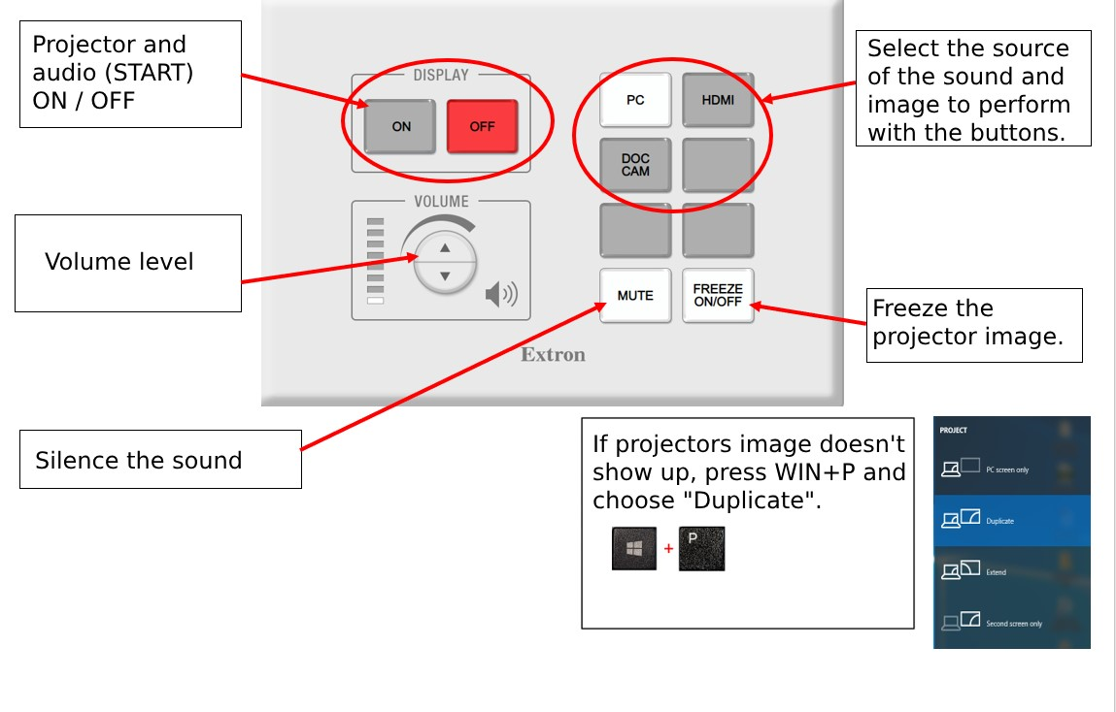
Apple Mac users
Connect to HDMI from your Mac: https://support.apple.com/en-us/108928
It would be wonderful if you have own HDMI-adapter with you.
Here's an instructional video to watch beforehand: How to Connect a Mac to a Projector: https://youtu.be/RwOCks0eo8k

Internet connection / Wi-Fi
UEF-OPEN | An open WLAN. Mainly for the use of visitors. Usage does not require a user account or a password.

We are offering technical support and help during the symposium’s time.

Anything else to ask?
tuomas.partanen@uef.fi +358505309015 (Whatsapp)
https://sites.uef.fi/symposium-for-music-scholars-2024/?lang=en
Thanks!

